Nepal College of Information Technology
Unit Test
Spring 2011
Program : BE ELX Time : 2 hrs
Semester : (VI) FM : 70
Subject : Filter Design PM : 35

- Candidates are requested to give their answer as far as practicable in their own words.
- The figure in the margin indicates the full marks
- Attempt ALL question

1 (a) What is filter ? How do we design them? (7)
(b) Describe the types of filter based on attenuation curves. (8)
2 (a) Realise the circuit for transfer function T(s)=s/(s+5).Use .01 uF capacitors only and avoid Inductors. (8)
(b) Plot the magnitude response of below circuit and identify the type of filter. (7)

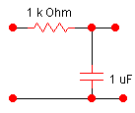

3 (a) Calculate the transfer function of 4th order Butterworth low pass response.Locate the poles of it. (8)
(b) Calculate the order and cut off frequency with ap=0.02 db,wp=1 rad/s,as=20db,ws=2rad/s having equiripple response in pass band. (7)
4 (a) Why frequency transformation is needed? Derive 3rd Butterworth HPF with cutoff frequency 20 kHz. (7)
(b) Obtain BPF and BSF for given LPF transfer n/w. Given w1=100rad/s w2=200rad/s and w1 and w2 are cutoff frequencies of required filters. (8)

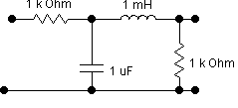
5. Write short notes on (2*5)
(a) Normalization and Denormalisation.
(b) Available Filter Design Technologies

